No bid option if not logged in, it should show bid now and when clicked it brings you to login/sign up page
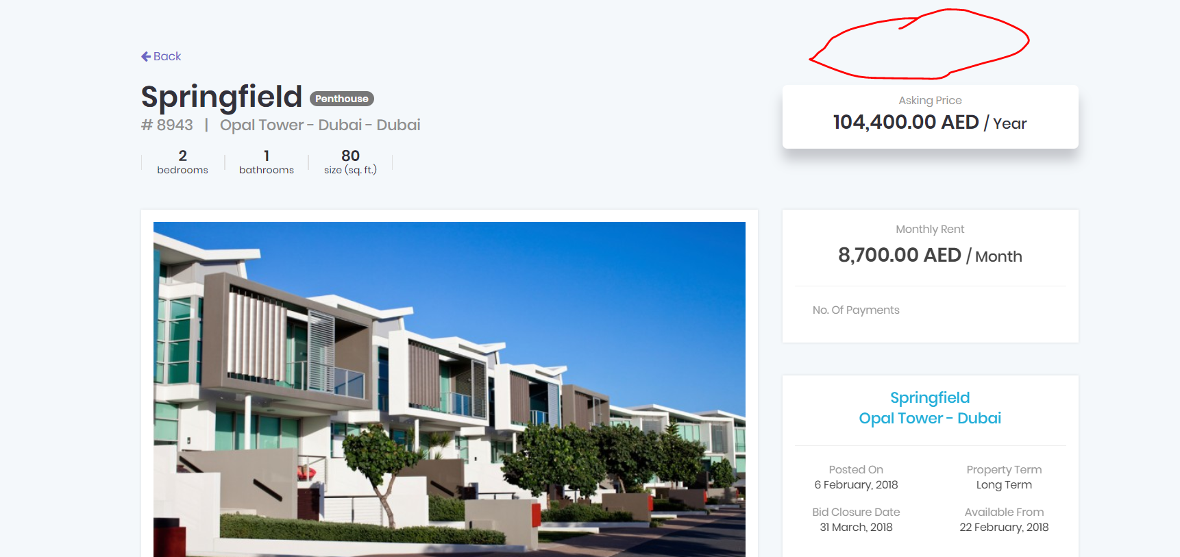

The message/note is still viewable, it should be disabled
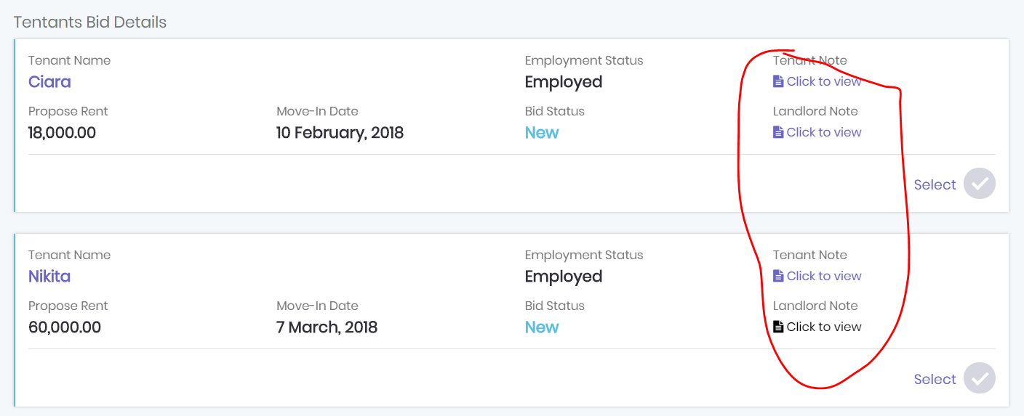
Show a message icon with counter
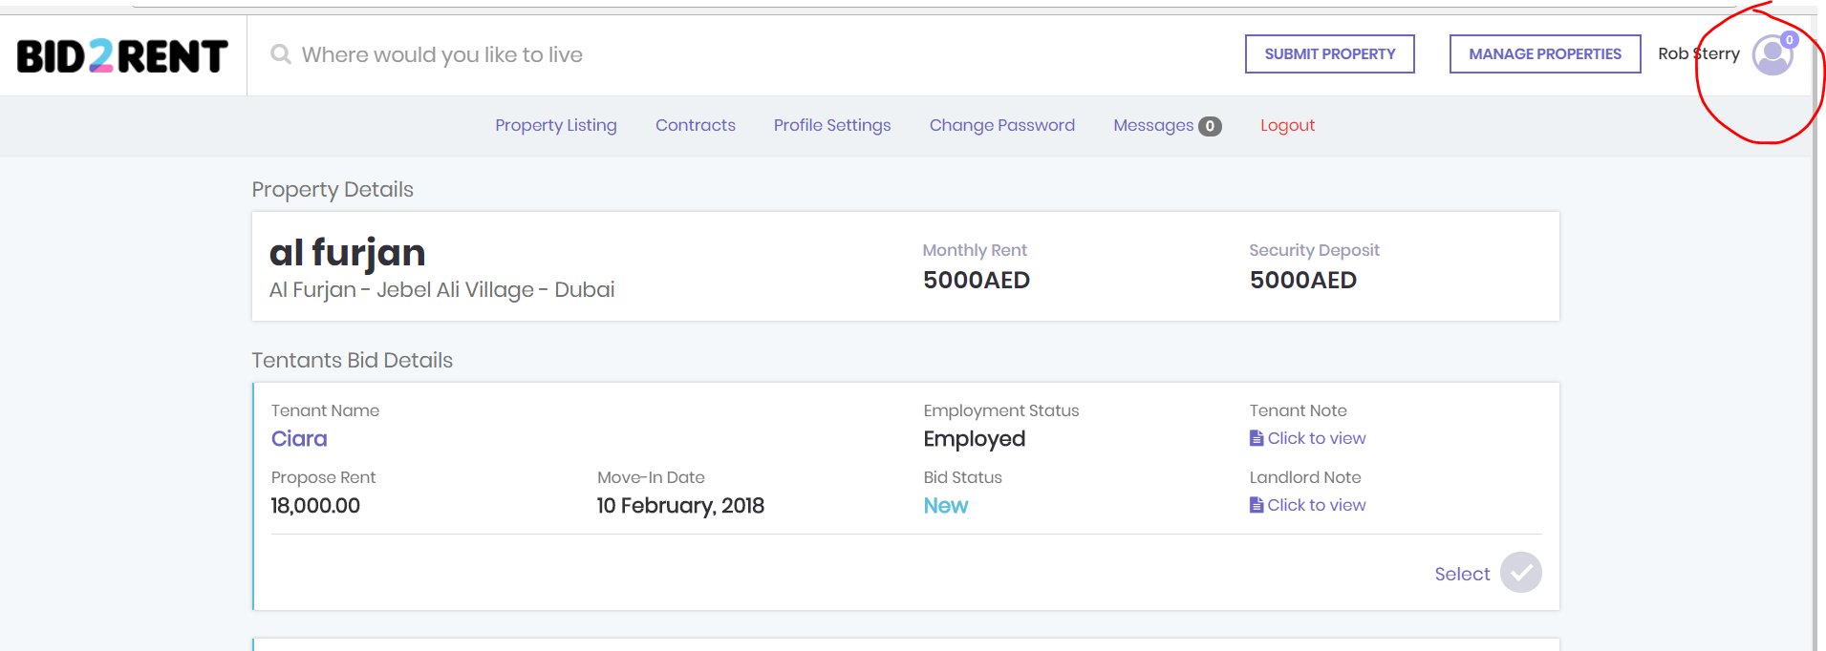
Add text: Upload property’s title deed; this is needed to verify the property, and is used to help the tenant apply for the Ejari
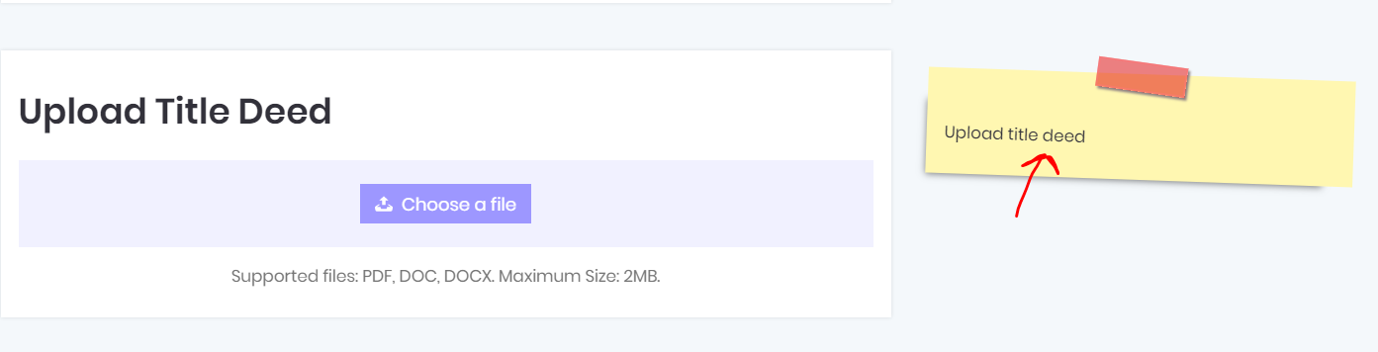

Options to add: no smoking,
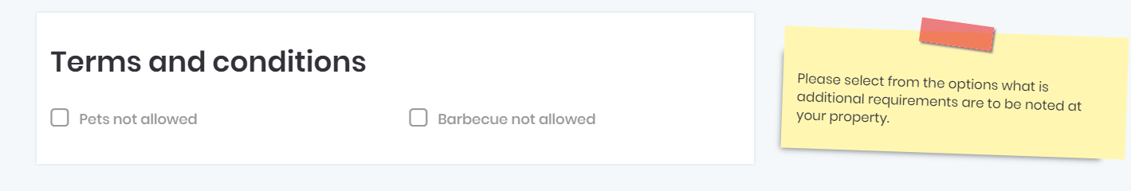

Add text: Grab the pin and locate your property so potential tenants have a good idea of the exact location
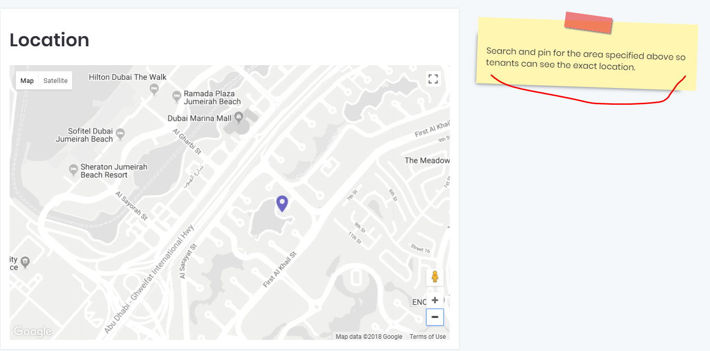

For change password, have a show characters button so they can check the password they entered
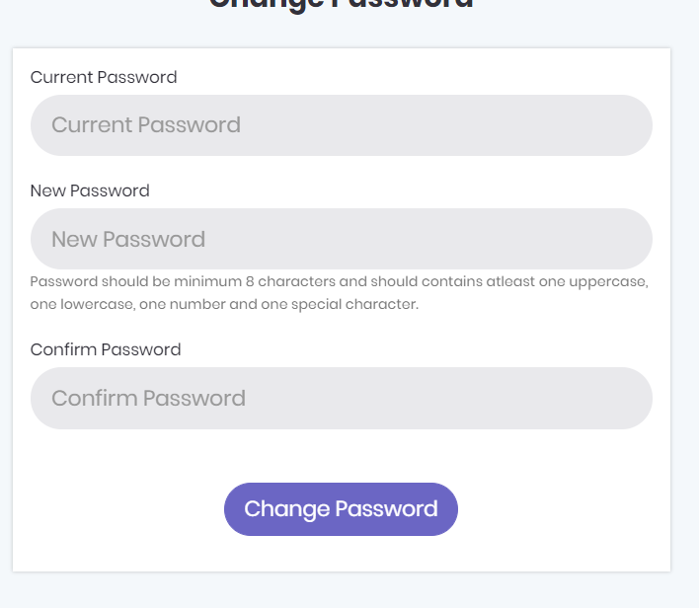
On landing page heading should read:
The Future of Renting, with you in Control
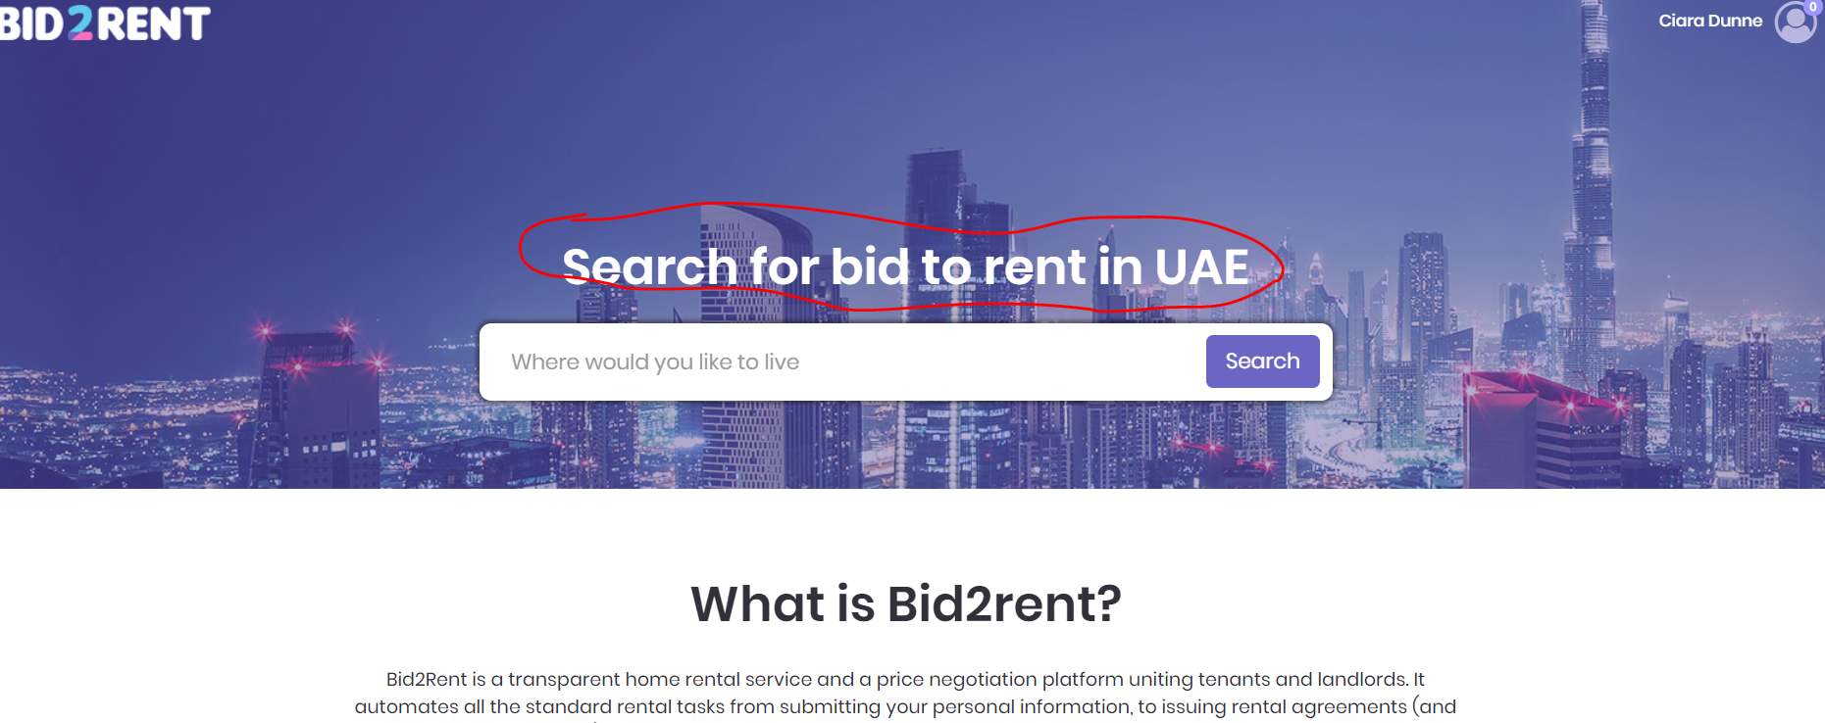

Property must be removed when the bid closes on date landlord selected, so only live , relevant properties are available for viewing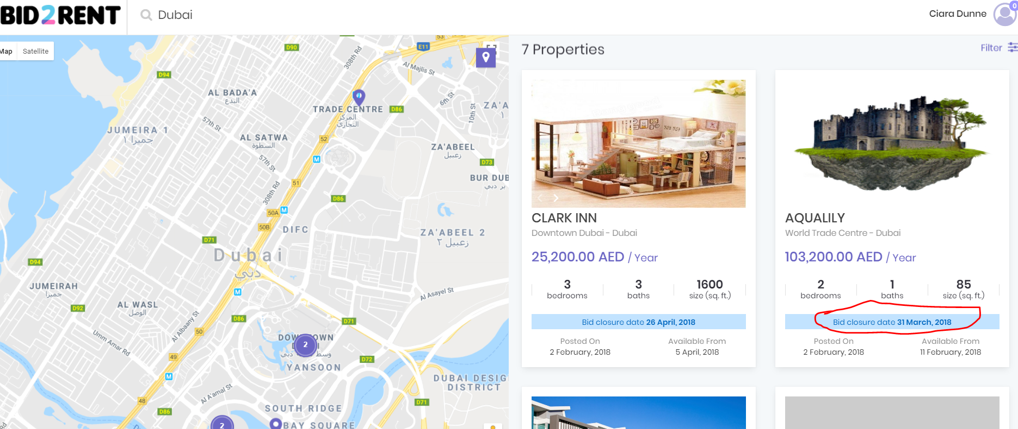

When submitting a property, Give a suggested security deposit of 5% of the yearly rent, also allow them to change if needed as more expensive villas will have a set amount not a percentage
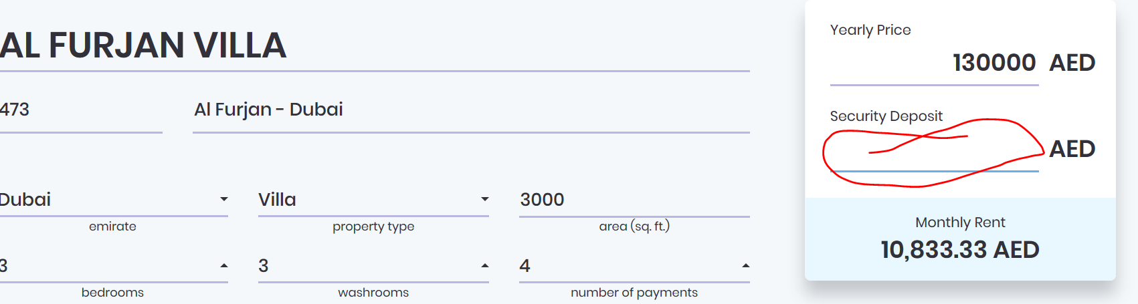

Should say:
Choose your viewing options for potential tenants.
Property is open for viewings
Property keys with building reception
No viewing available
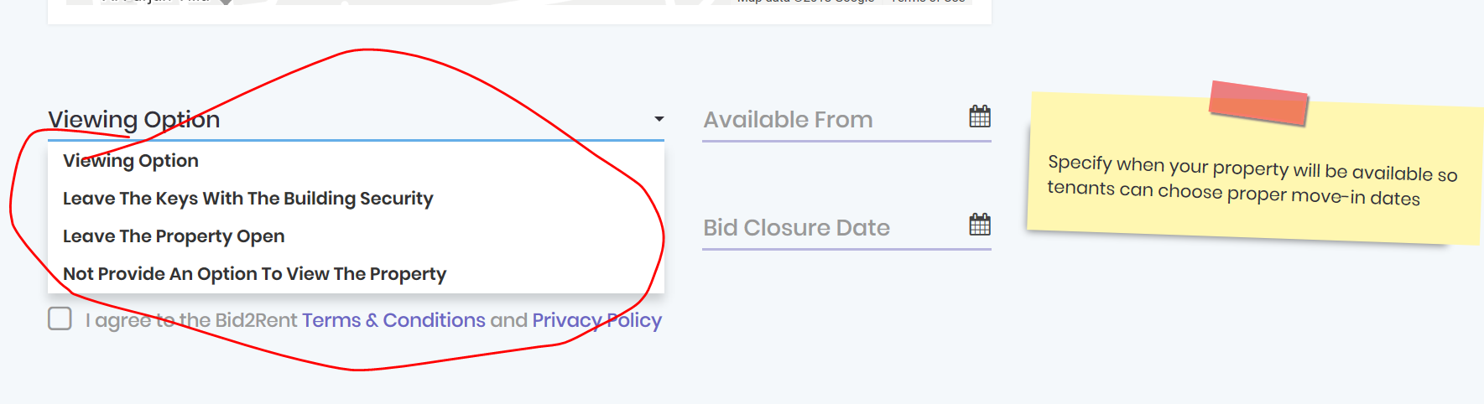
When submitting property they choose property term, if they choose long term it should show 1 year, if the choose short term it should allow them to choose a number of months, 1 to 11.
Right now it doesn’t explain what the difference is, also needed to construct the contract
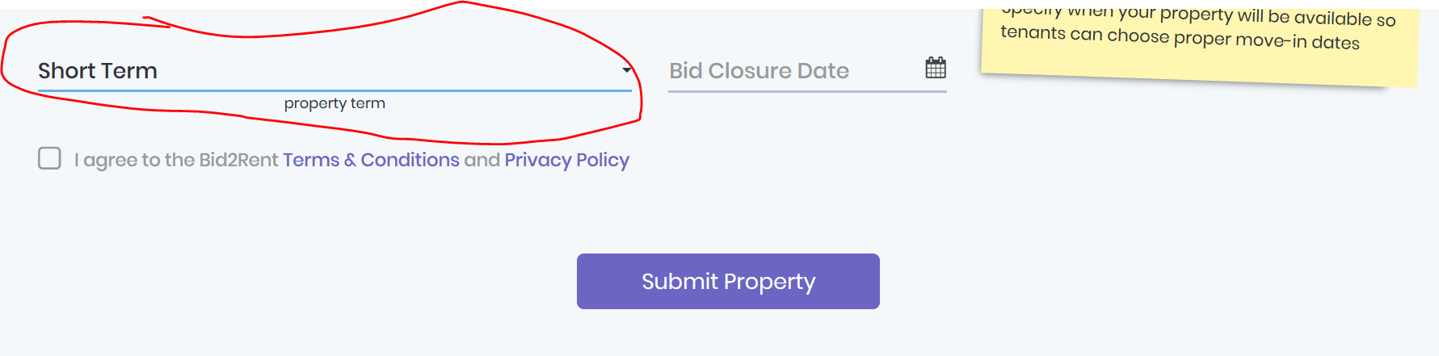
Change text:

Ok nearly done!
Just to add the date your property is available from, which date you would like to close the bidding
Select long or short term rental of your property.
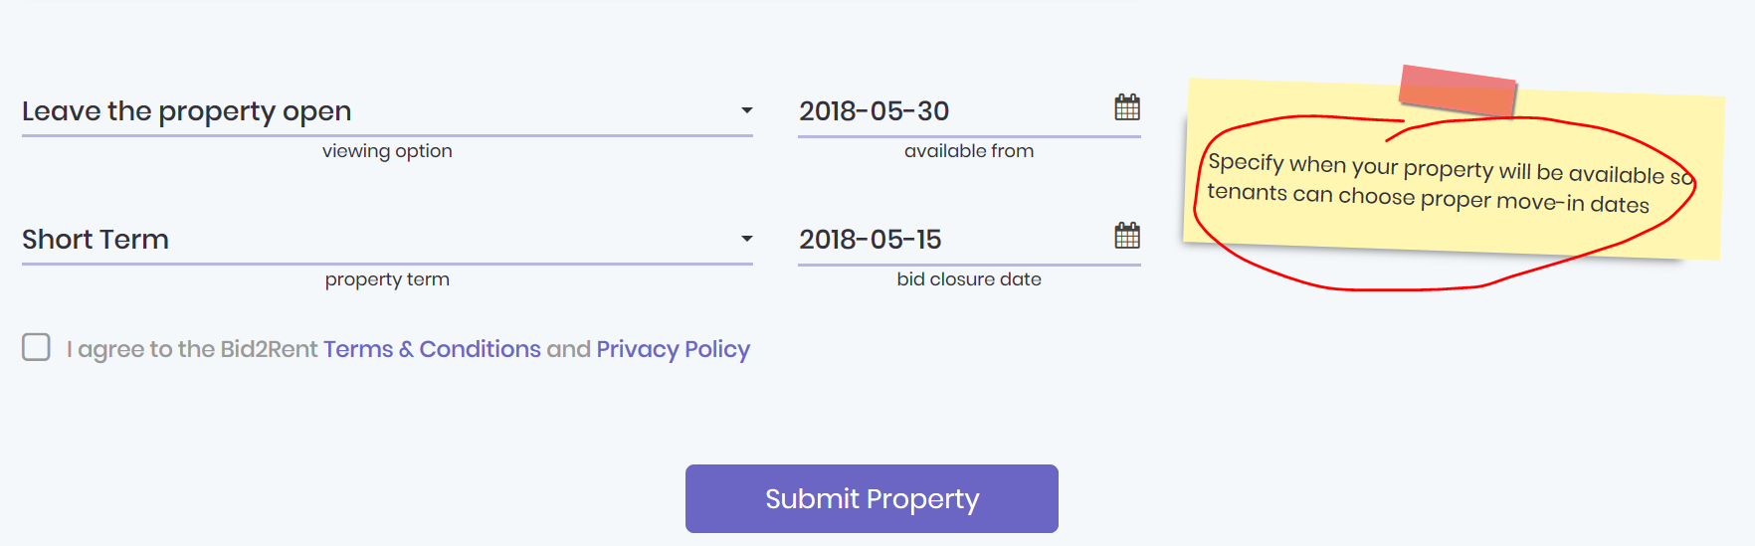

Getting an error when trying to submit, I used Microsoft edge.
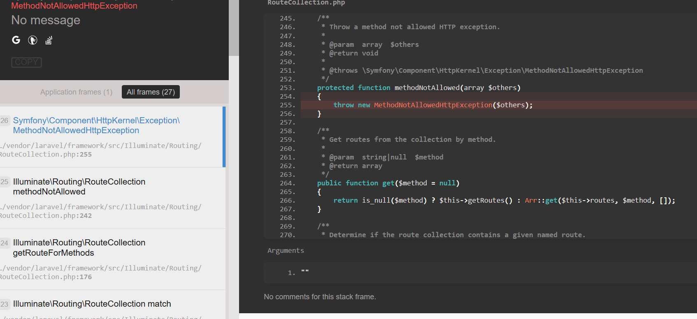
Correct the spacing on the close button in the filters box 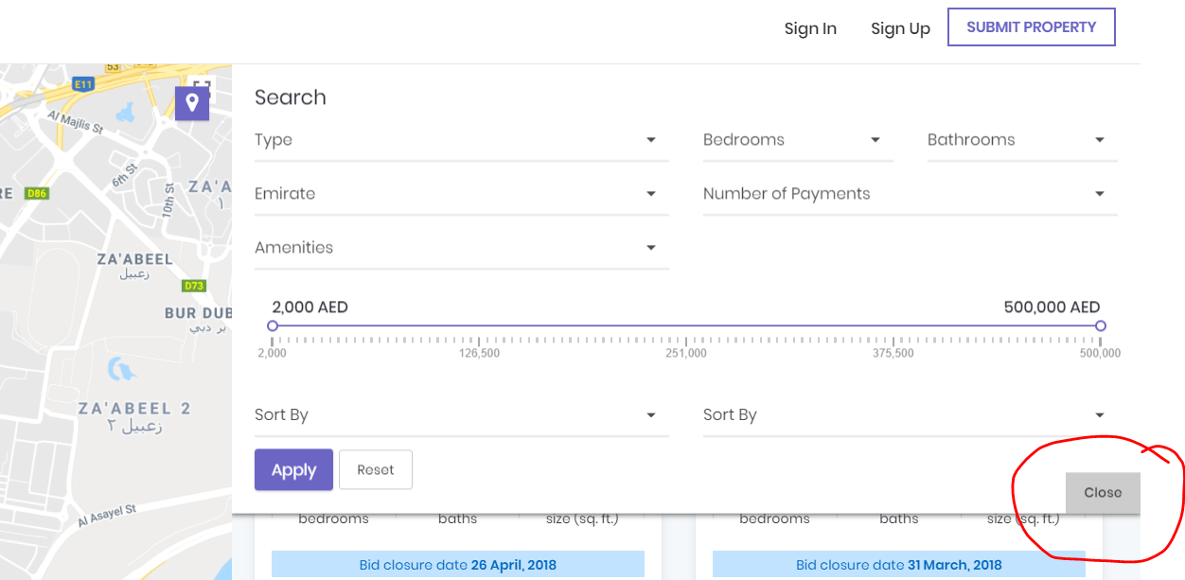

Fix the filter for price, to go up in 5k even amounts
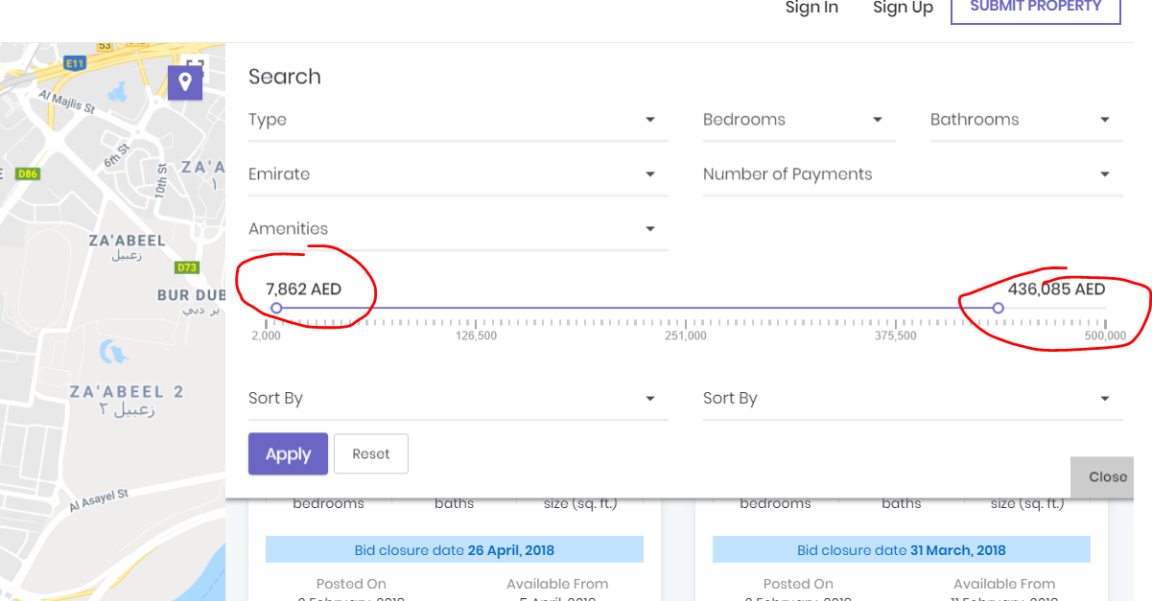

Sort by on filters box, should say “sort by date” and drop says “newest to oldest” and “oldest to newest”
Then “sort by price” and drop down says “highest to lowest” and “lowest to highest”
